The Elemental colour pallette has been designed to make shopping & getting ready easier.
By having a pallete of colours that compliments each other makes mixing and matching outfits a breeze. Plus when you buy new clothes you know it will go with what you already have.
Three ways you can jazz up your wardrobe with a colour chart
- Buy accersories with mixed colours that suit your pallette. They will pull your outfit together.
- Dress according to your body type so that all your clothes fit well.
- Buy timeless pieces & classics like the leather jacket, the hoop earings, the denim skirt and then incorporate your own style with them.

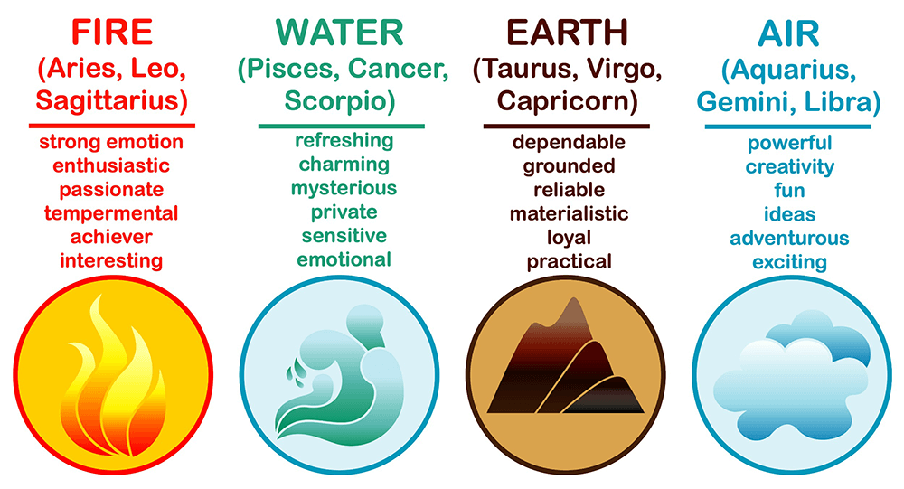
- To Purchase your colour pallette as an e-copy is only £4.99
- For homework – create a Pinterest board of a celebrity who’s style you admire.
- Send them to me @...

Air – Think of all of the types of sky
- Night sky
- Pink & Orange evening skies
- Bright blue sunny day skies
- Grey cloudy skies

Earth – Think Autumn & Christmas Colours
- Dusky version of the colour i.e burnt orange, mustard, khaki green
Fire Sign – Think FIRE OBVS
- Bright Colours
- Volcanos & Mountains
- Vibrant & Fierce
Water Sign – Think of Seas, oceans, coral reefs, rivers & lakes
- Pastel / Baby coloured versions of any colour i.e. baby pink, baby blues

